**Eukaryotes are surprisingly important and transcriptionally active in extremophilic desert microbiome**

Gherman Uritskiy, Diego Gelsinger, Adam Munn, Michael Tisza, James Taylor, Jocelyne DiRuggiero

**ABSTRACT**

Microbial communities play a dominant role in the biosphere and, as such, understanding the mechanisms underlying their functional adaptations to environmental conditions is critical for predicting their behavior. Compared to metagenomic approaches, which offer a limited view of a microbiome’s capabilities, metatranscriptomic analyses allow for interrogation of real-time adaptations of a microbial community. This aspect of microbiome functioning has not been well characterized in natural high-salt environments. To address this knowledge gap, and to build a general framework of relating the genomic and transcriptomic components of endolithic microbiomes, we performed a robust meta-omic survey of extremophile communities inhabiting halite (salt) nodules in the Atacama Desert. We found that the major phyla of this halophilic community have strikingly different levels of total transcriptional activity, and upregulate different metabolic pathways in their transcriptomes. Most surprisingly, we report that a novel *Dolichomastix* alga – the only Eukaryote found in this system – was by far the most active community member, producing the vast majority of the community’s photosynthetic transcripts despite being outnumbered by members of the *Cyanobacteria* phylum. The divergence in the transcriptional landscapes of these segregated communities compared to the relatively robust metagenomic functional potential also suggests that microbiomes in each nodule undergo unique transcriptional adjustments to adapt to the local conditions. Finally, we report and characterize several previously unknown halophilic viruses, many of which exhibit transcriptional activity indicative of host infection. Taken together, our characterization and comparison of the metagenomic and metatranscriptomic elements of halite microbial communities allowed for inference of novel insights into the functioning of halophilic microbiomes.

**INTRODUCTION**

While transcriptional and metabolic activities of human-associated microbiomes are being actively explored, little is known about these aspects of microbial community functioning in environmental microbiomes, particularly in high-salt environments (1). A few select halophiles have been extensively studied in isolation (2), and the genomic components of some high-salt natural microbiomes have been partially de-convoluted with advancements in metagenomics (3) however the transcriptional and metabolic activities of such communities remain understudied (1, 4). To address this knowledge gap, and to investigate the relationship between the functional potentials and functional activities of extreme microbiomes, we interrogated the metagenomic and metatranscriptomic components of halophilic endolithic (inside-rock) microbiomes found in the Atacama Desert, Chile. Despite an average annual precipitation of less than 1mm (5) microbes have evolved to survive here by living inside halite nodules (porous salt rocks), where they rely on atmospheric moisture absorbed by the salt through deliquescence (3, 6). Encased in rocks, halite communities have minimal biomass and nutrient exchange with the outside, making them an interesting ecology model for studying general microbial community assembly principles and the effects of climate change on microbiomes (7).

Previous studies of halite nodule microbiomes reported their general genomic composition (3) as well as temporal turnover (7) and long-range spatial distribution dynamics (8). The halite microbiomes rely on carbon fixation by a single species of halophilic alga and 1-3 species of cyanobacteria, which support a number of heterotrophs, including *Halobacteria* and *Bacteroidetes*, which constitute the majority of the system’s biomass (3, 8). Halophile viruses have also been documented in the community, with some of their putative hosts predicted with matches to cellular CRISPR spacers. Similar to other water-limited biomes, the halite microbial community composition and diversity is largely dependent on water availability (6, 8). With this in mind, the humidity and temperature swings in the salar throughout the diurnal cycle likely have an impact on microbiome functioning.

While recent environmental microbiome studies have largely focused on the metagenomic component, the genomic composition of microbial communities does not necessarily reflect their functional activities. In a previous study of atmospheric microbiomes, comparative multi-omics showed that different taxa can contribute to varying degrees to the metagenomic and metatranscriptomic components of the microbiome (9). However, transcriptomic studies are difficult to conduct in most extreme environmental microbiomes due to low available biomass and extremely high sample complexity (4). A study of microbiomes found in hot springs revealed the pathways the microbial populations were actively expressing at any given point in time (10). In an alkaline lake, metatranscriptomic analysis of the communities inhabiting varying depths allowed the researchers to identify key pathways contributing to sulfur and arsenic cycling, and the organisms contributing to each process at varying depths (11).

Investigating the meta-omic components of partially segregated communities can also offer unique insight into the deterministic and stochastic factors contributing to community function. Recent studies of the metagenomes of small isolated microbiomes such as those found in bromeliad rosettes (12) or separated salt formations (13) revealed that such communities converge to very similar high-level taxonomic and functional potential landscapes when subject to similar external conditions, while stochastically diverging in terms of their fine-scale (strain) composition. In hydrothermal vents a similar approach revealed that microbial populations in distinct microbiomes diverge at the transcriptional as well as functional potential levels (14). However, it remains to be seen how the variance in the metagenomic components of segregated communities compare relate to that of the transcriptional elements. One hypothesis is that their metatranscriptomes converge on a similar activity landscape just like their functional potentials. On the other hand, it is also possible that rapid adaptations to unique and transient changes in each isolated community force their metatranscriptomes to diverge.

**RESULTS**

**Community taxa vary in their contribution to the metatranscriptome**

The endolithic halite microbial communities have been well described in terms of their metagenomic components, in particular their taxonomic distribution (3). Here, we contrast the taxonomic composition of the halite metagenome with that of the metatranscriptome, as determined by aligning RNA reads to the taxonomically-annotated metagenomic assembly (Fig. 1). This comparison highlighted core differences between the community taxa abundance (fraction of DNA reads) and overall gene expression levels (fraction of RNA reads), as the transcription of several taxa are over- or under-represented with regard to their prevalence in the community. Most strikingly, the total transcriptional activity of Eukaryotes in the community was much higher than their genomic abundance would indicate. Indeed, 12% of non-rRNA metatranscriptomic reads were mapped back to Eukaryotic contigs, compared to only 1% in metagenomic reads. In contrast, Bacteria – particularly Bacteroidetes – represented a smaller fraction community metatranscriptome compared to the metagenome (8% vs 15%).



*Fig. 1: Taxonomic composition of the halite community as estimated from the metagenome (A) and metatranscriptome (B). The relative compositions were estimated from the read coverages of contigs belonging to the respective taxa.*

When interrogating the transcriptional levels of individual contigs, MAGs, and taxa relative to their abundance, we also find significant differences in their activity levels. Contigs of different taxa display drastically different transcriptional activity levels, which are not necessarily correlated with their abundance levels (Fig. 2A). In particular, the three phototrophic species –*Halothece* and *Euhalothece* cyanobacteria and a *Dolichomastix* green alga – display similar average gene transcriptional levels despite being present at notably different genomic abundances. Most strikingly, the algae contigs (shown in black) display extremely high levels of transcriptional activity (y-axis), despite being present at very low genomic abundance (x-axis). On the other extreme, *Nanohaloarchaea* (shown in blue) have very low gene transcription levels given and are present at very low abundance. The transcriptional activity levels of most other taxa are proportional to their abundance, although significant variation in the transcription activity ratio is observed within the highly diverse groups of *Bacteroidetes* and *Halobacteria* (the dominant class within the *Euryarchaeota* phylum).

Further quantifying the relationship between abundance and transcription levels in each taxon (Fig. 2B) or metagenome assembled genome (MAGs; Fig. 2C) further supports that the Chlorophyta (algae) in the community is an order of magnitude more active than most other taxa in this community. When considering the total number of transcripts contributed (circle diameter), it is clear that algae contribute more to the metatranscriptome than both of the other phototrophs combined. When considering the chromosomal, mitochondrial and chloroplast genomes of the algae separately (Fig. 2C), we see that the organelle genomes are present in much greater numbers than the main genome (approximately 10X for mitochondria and 20X for chloroplasts). Mamiellophyceae green algae have been characterized to have a single mitochondria and chloroplast, so these coverage differences suggest there are multiple organelle genomes in each organelle, consistent with previous findings in green algae. The chloroplast genome is also much more abundant and active than the more abundant Cyanobacteria (*Halothece*), which in combination with their high transcriptional activity leads to chloroplasts contributing equal numbers of transcripts to Halothece despite being nearly two orders of magnitude smaller in genome size (95Kbp vs 3,577Kbp).

While some taxa are more transcriptionally active than others, the relative activity of individual contigs and MAGs also changed between the replicates. Indeed, the transcriptional activity of MAGs (expressed as the ratio of total RNA expression to the total DNA abundance) changed significantly between samples (Fig. S1). Directly comparing the abundance and transcriptional levels of any given MAG across the replicates (Fig. S2C) also revealed that for the majority or organisms, their total transcription and abundance are not tightly correlated (Fig. S2D). These findings were also verified at the assembly level to check for binning biases (Fig. S2A,B). Together, these results show that the transcriptional activity levels of individual species change between samples.



*Fig. 2: (A) The relative total transcriptional activity (y-axis) of contigs in relation to their abundance in the metagenome (x-axis). (B) The total contributions to the metatranscriptome (circle size) of the major taxa, shown in relation to the average abundance of their individual taxonomic components at the contig scale (y-axis) and transcriptional activity to abundance ratio (x-axis). (C) A similar summary of total transcriptional activity, but shown in the individual high-quality MAGs. The total transcriptional activity of a given contig or MAG was estimated to be the median read expression (TPM) of its genes. The total abundance was estimated from its average DNA read coverage.*

**Virus diversity and transcriptional activity [Mike please add to and expand]**

To further investigate the transcriptional differences across different samples we looked at the viral components of this community. Using protein sequence homology, we extracted 91 viral contigs ranging in size from 5Kbp to 50Kbp. Viral transcription activity implies that the virus is undergoing active infection of a host cell, which suggests that the activity of a given virus in a sample is dependent not only on its abundance, but on its infective success. Consistent with this, we found that a virus’s abundance does not effectively predict its activity levels. In a given sample, many active viral contigs were not highly abundant, and highly-abundance contigs were not necessarily active. Indeed, computing the Pearson correlation of viral abundance to viral transcriptional activity revealed that only 12 out of the 91 viruses showed significant positive correlation. It is likely that these highly correlating viruses are likely integrated in their host’s genome and thus maintain constant base-level transcription.

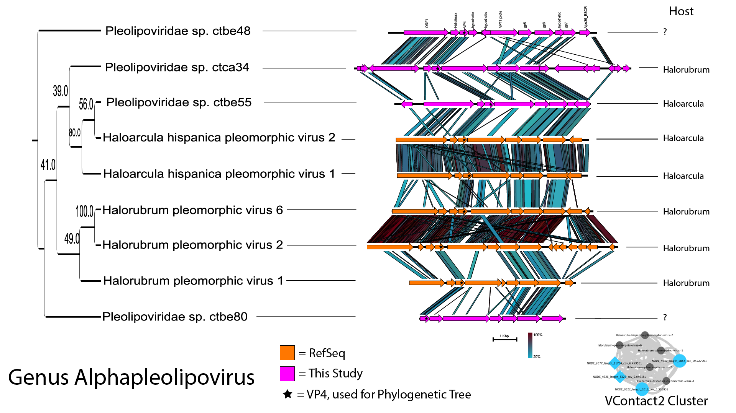

*Fig. 3: Some kind of figure showing the viral taxonomy, phylogeny, host, abundance, and expression. This will be the main virus figure, so aesthetics matter.*

**Characterization of putative genome of novel *Dolichomasti*x alga**

Through a combination of assembly and binning methods we reconstructed the alga chromosomal, chloroplast, and mitochondria draft genomes. The metatranscriptome was also assembled to obtain the complete sequence of the 18S rRNA sequence from the aforementioned halite algal genome. This sequence was found to be 94% identical to a putative *Dolichomastix* alga found in lake Tyrell (15). Additionally, reconstruction of a Chlorophyta phylogenetic tree from the sequences available in the SILVA database (Fig. S6A) reveals that the halite alga is most closely related to other members of the *Dolichomastix* genus (Fig. S6B).

Comparing the relative contributions of the phototrophs to the functioning of the community in terms of photosynthesis revealed that the novel algae contributes significantly to this pathway. We identified several key genes from the photosynthetic pathway that were annotated and present in all three phototrophs found in this community – the alga *Dolichomastix* and the Cyanobacteria Halothece, and Euhalothece (Fig. 4). In almost every single photosynthetic gene, the algae contributed an order of magnitude more transcripts than both of Cyanobacteria combined. These results suggest that not only is the alga disproportionately active given their low abundance in the samples, but also that it is the major contributor of photosynthetic transcripts. If the photosynthetic gene transcriptional levels are assumed to be proxies to photosynthetic activity, it can be inferred that algae are the major primary producers of this community.

Given the high importance of *Dolichomastix* alga for community carbon fixation, we further characterized its genome in relation to its closest fully sequenced phylogenetic relatives *Ostreococcus tauri* and *Micromonas pusilla* (marine algae), and another halophilic algae *Dunaliella salina*. The extracted halite chromosomal genome was 10.3Mbp long, compared to 13.1Mbp in *O. tauri*, 22.4Mbp in *M. pusilla*, and 343.7Mbp in *D. salina*. Given the lack of reliable methods to estimate Eukaryotic MAG completion levels, we cannot directly compare the genome size of the Dolichomastix MAG to the other algae, however manual curation of the MAG with alignment based methods suggest reliably low levels of contamination. All four genomes were functionally annotated with the same method and the isoelectric point (pI) or each gene was estimated (Fig. S7A). The differences in predicted p*I* distributions of the genomes revealed potential differences in the intra-cellular environment. We found that the pI distribution of the *Dolichomastix* halite alga is relatively similar to its closest relatives *M. pusilla* and *O. tauri*. However, the non-halophilic relatives of the halite algae displayed a trimodal pI distribution curve, with a notable fraction of the genes predicted to encode for proteins with a pI of 10.5 or greater. *Dolichomastix* on the other hand, lacked this third peak, similar to a distant but halophilic algae *D. salina*. Of the few proteins in *Dolichomastix* that were still predicted to be highly alkaline (*pI*<11), the majority were histone and DNA-associated proteins, which need to be alkaline to maintain function.

To investigate whether the genes encoding for high pI proteins in *M. pusilla* and *O. tauri* were still present in the *Dolichomastix spp.*, we aligned the amino acid sequences of the *M. pusilla* and *Dolichomastix spp.* genomes . Of the 105 *M. pusilla* genes encoding for alkaline proteins that were found to have homologues in *Dolichomastix spp.*, 80 had encoded for proteins with a significantly lower p*I* in the *Dolichomastix* homologue (Fig. S7B). These acidified proteins did not belong to any specific functional pathway or cellular compartment, but many were chaperones, mRNA processing proteins, and DNA-binding proteins.

To further compare the halotolerant *D. salina* and *Dolichomastix* *spp.* genomes, we found homologs of important high-salt adaptations proteins. In two previous proteomic studies, *D. salina* was subjected to increasing salt concentrations to identify 51 cellular and 46 membrane-bound proteins that were upregulated under high-salt stress (16, 17). These genes were aligned against the *Dolichomastix* genes to find 33 homologous genes that could play a role in the high-salt tolerance. Of these, all the genes were actively expressed in *Dolichomastix*, and a significant majority were highly expressed (Fig. S7C). In particular, we identified several highly expressed chaperones and heat-shock proteins, as well as a number of mitochondrial and chloroplast genes. This suggests that *Dunaliella* and *Dolichomastix* may share similarities in their adaptations to high salinity.



*Fig. 4: The expression of key photosynthetic pathway genes of the major halite community phototrophs that were identified in all 3 genomes.*

**Major highly expressed functional pathways in the community**

Investigating the expression of functional pathways from the KEGG Brite pathway in reference to their abundance in the metagenome allows us to interrogate the upregulated transcriptional activities of this community (Fig. S8). The relative abundance of each gene in the DNA samples was estimated from the DNA coverage of the contig that it lies on, expressed in copies-per-million reads (CPM), while the relative expression level of the genes was expressed as transcripts-per-million reads (TPM). The total abundance (CPM) and transcriptional activity (TPM) of pathways were estimated by combining abundances and expression level of the genes that constituted each pathway. Only pathways that were predicted to be present in the metagenome (see methods) were considered, and standardizing to an equal sum of pathway TPM or CPM. Most highly-expressed pathways such as translation, and nucleotide metabolism were also present in high levels in the functional potential (Fig. S8). Photosynthesis, however, was not only one of the highest expressed pathways in the community, but also had relatively low levels of abundance at the DNA level. Similarly, the opsin production pathway was expressed at relatively high levels when taking into consideration its low abundance in the functional potential. By comparing pathway abundance to their total expression, we are able to infer which pathways were transcriptionally prioritized by the community.

Furthermore, by standardizing to the maximum value (abundance or expression) in each pathway, we were able to visually compare the relative expression of each pathway in relation to its abundance in the metagenome (Fig. 5). The community metabolic pathways were divided into three groups – those that were expressed lower, higher, or equal to their respective abundances in the community’s functional potential. Clustering between RNA replicated did not represent the sampling time-points or the taxonomic composition. Among the lowly-active pathways, we found cellular membrane and cell wall components, including most lipid metabolism and synthesis pathways, and glycan biosynthesis. In contrast, in the highly expressed pathway group, we found functions essential to the functioning to this endolithic community such as the two major metabolic pathways for carbon fixation and utilization – photosynthesis and oxidative phosphorylation, respectively. The other group of highly expressed pathways dealt with protein synthesis and processing. In particular, multiple pathways for transcription and translation were very active, as were pathways for protein folding, trafficking, and degradation.



*Fig. 5: Relative prevalence of major KEGG functional pathways in the metagenomic (red) and metatranscriptomic (blue) samples. The pathway abundance (DNA) and expression (RNA) value were the combined total CPM or TPM (respectively) of the genes that constitute that pathway. All samples were standardized to an equal total coverage of all pathways, and then scaled to the maximum value for each row (pathway).*

**Pathway expression enrichment in major taxa**

By computing the ratio between the standardized pathway expression to pathway abundance (in the metatranscriptome and metagenome, respectively), we could further explore the pathways that community members prioritized for transcription. Importantly, these ratios do not represent a taxon’s overall functional landscape, but rather the degree to which it prioritizes the expression of a pathway. We computed these ratios for the community's major taxonomic taxa – *Halobacteria, Bacteroidetes, Chlorophyta* (green algae), *Cyanobacteria*, *Proteobacteria, Actinobacteria, and Nanohaloarchaea* – to compare and contrast the transcriptional priorities in these groups (Fig. S9).

While each major taxon in the community had a unique transcriptional profile, we found there to be many similarities between their highly expressed pathways. For all major taxa except for *Nanohaloarchaea*, protein folding, sorting, and degradation pathways were very among the most highly expressed pathways. General carbon metabolism and oxidative phosphorylation were also highly expressed, although the specific sugar metabolism pathways were highly varied. The community's least active members – the *Nanohaloarchaea* – where the most different from the other community members. Their only highly-expressed pathways were for nucleotide metabolism, transcription and translation as well as pathways for metabolizing simple sugars such as such as fructose and pyruvate. Using manual BLAST alignments, we also identified fragments of the SPEARE gene in two of the MAGs (T17_Nanohaloarchaea_45_3 and T17_Nanohaloarchaea_46_6), however none of them were expressed in the metatranscriptome. Not surprisingly, the two phototroph groups in the community – *Chlorophyta* and *Cyanobacteria* – clustered together in their transcriptional activity, as they were the only groups to carry and express the photosynthesis pathway, which was highly active in both taxa. However, the other metabolic activities in the two phototrophs was quite distinct, with *Chlorophyta* strongly prioritizing glyoxylate metabolism, while *Cyanobacteria* prioritized fructose and pentose metabolism. The opsin production pathway, which was one of the most upregulated pathways in the metatranscriptome compared to the metagenome, was predominantly expressed in *Halobacteria*.

**No transcriptional differences detected between daytime and nighttime**

Samples for metatranscriptomic (and the corresponding metagenomic samples) were collected at 2 time points during the diurnal cycle – 9 am and 9 pm – with 6 replicates each, to uncover temporal transcriptional adaptations of community members. The 9am time point was characterized by bright light (1h after sunrise) and high relative humidity (60%-80% RH) conditions, while the 9pm time point was collected in the dark (3 hours after sunset) and at low humidity (40%-50% RH). Differential expression analysis was done on the entire community, standardizing the gene expression to the abundance of its contig in the DNA or the total contig expression in the RNA (Fig. S10A). DESeq identified differentially expressed genes, however the false discovery rate was greater than 5%, and the over- and under-expressed genes belonged to a seemingly random set of pathways. This analysis was also repeated for individual high-quality MAGs (>70% completion, <5% contamination), particularly the Cyanobacteria and Dolichomastix MAGs (Fig. S10B,C). This analysis included a much more robust standardization scheme that accounts for the abundance (or total expression) of the entire organism, but did not yield any significant differentially expressed genes.

**The functional profile is more variable than the functional potential**

To address the high inter-replicate metatranscriptome variation and to investigate how pathway abundance and pathway transcription differences contribute to this heterogeneity, we standardized the KEGG pathway abundance or expression values of each pathway across the replicates to range from 0 to 1, and computed their variance (Fig. 6). The resulting data allows for comparison of the variance in pathway abundance to the variance in pathway expression in the whole community or a taxon of interest. We found that across all tested taxa, the variance in pathway functional potential significantly lower than the variance in functional expression (Fig. S11). This suggests that while the overall commercial potential of these communities remain stable between replicates, which is consistent with previous findings, their transcriptional activity changes significantly in individual halite nodules.



*Fig. 6: KEGG pathway (A) CPM abundance and (B) TPM expression in sample replicates, standardized to the highest value in each column. Tracks below the heat maps show the CPM of TPM values from individual replicates, standardized to the average between all the replicates.*

**DISCUSSION:**

Recent rapid advances in sequencing technology and metagenomic sequence analysis software enabled researchers to interrogate and study halophile adaptations and functioning in their native high-salt environments (7, 8). To date, however, the metatranscriptome of sigh-salt microbiomes remains largely understudied, with no comprehensive study to describe the transcriptional activities of halophiles in naturally occurring systems (1). Our detailed interrogation and comparison of the metatranscriptomic and metagenomic components in a halite model ecosystem provided several new key insights into the functioning of halophilic and segregated endolithic microbial communities.

One of the striking qualities of these halite endolithic communities is their high inter-replicate variance. While the metagenomic functional potential varies between the samples, the inter-nodule transcriptional differences were much greater. These differences were detected both in the overall functional landscape of the community as well as in the transcriptional activities of individual genomes. The varied transcriptional profiles of individual halites likely stem from a combination varying rock topology, humidity and temperature metrics, inter-cellular interactions, and stochastic factors, which we were unable to measure due to limitations and compounding factors in this study. Previously, water has been described as the major driving factor of the taxonomic diversity in this desiccated environment (8, 13, 18). It is likely that water availability also affects the transcriptional adaptations of this community. In particular, it is likely that internal humidity can vary significantly from nodule to nodule depending on their capacity for water retention, which in turn could depend on structural characteristics such as size, degree of porousness, and shape (19). However, the relative convergence of functional potential of the halite community pan-genome is primed to survive in a range of conditions. One explanation for this is that the differences in water availability are transient, as the halite nodules “recharge” after every high-humidity night through deliquescence (20), which forces the microbial communities to maintain relatively similar functional potentials to be able to thrive in any condition, to which they then adapt transcriptionally.

This inter-halite transcriptional variation likely explains out inability to detect significant transcriptional adaptation of the community and its members to the different environmental conditions throughout the day (i.e. morning and evening). Previous studies in this system were able to detect photosynthetic activity differences at night and day with absorbance measurement, however we were unable to replicate these finding at the transcriptional level (5). Instead, we found that the background noise from high inter-replicate variation in the metatranscriptomic landscape concealed any differential expression between the time points.

Comparing and contrasting the taxonomic composition of the metagenomic and metatranscriptomic elements of the halite community revealed that the different taxonomic groups displayed drastically different levels of transcriptional activity relative to one another. As such, we find that the previously reported community’s composition (6) does not accurately reflect the organisms that contribute to the community’s functioning, as has also been found in other microbial community with characterized metatranscriptomic components, including extremophile (14) and human-associated microbiomes (21). Similar other subsurface environents in which all domains of life are transcriptionally active (22), this model system presents an opportunity to compare transcriptional contributions of vastly different community members. One of the least transcriptionally active members in the halite microbiome – Nanohaloarchaea – had minimal and sometimes undetected levels of transcription. Recent characterization of Nanohaloarchaea suggests that they are ecto-parasitic, requiring direct contact with a host archaeal cell to uptake nutrients using SPEARE proteins (23). The low overall transcriptional levels as well as undetectable expression of the SPEARE proteins in any sample suggests that the Nanohaloarcahea were likely inactive and not associated with a host at the time of sampling.

Most strikingly, the most transcriptionally active organism in this prokaryote-dominated community is an alga – the only Eukaryote. The novel halophilic *Dolichomastix spp.* alga is responsible for producing nearly 12% of the community’s non-ribosomal transcripts despite representing only 1% of the community’s metagenome. Previous studies have identified notable Eukaryotic components in hypersaline environments (6, 15), however none have directly compared the transcriptional or metabolic contribution of Eukaryotes and Prokaryotes to learn how relevant they are to the community function. The larger cell size of green algae compared to Bacteria and Archaea, more efficient transcriptional machinery, and faster basal metabolism required to survive in a high-salt environment could explain this discrepancy. Broad estimates of the number of mRNA transcripts per average cell suggest 103-104 mRNA per Bacterial cell and 105-106 mRNA for a 3000 μm3 Eukaryotic cell (24). From a past microscopy-based observations of the halite alga, its volume can be roughly estimated to be roughly 1000 μm3, assuming a spherical cell shape (6). Taken together, these estimates suggest that the halite alga is expected to have 10-100 times more transcriptionally active than the prokaryotic species, which is similar to what is observed in this study. This striking transcriptional overrepresentation of a small Eukaryotic component in a microbial community is similar to what was found in a cow rumen microbiome, where a similar multi-omic comparative study revealed that Eukaryotic transcripts were significantly enriched over prokaryotic transcripts (25). We also found that the alga is responsible for producing the vast majority of the photosynthetic transcripts in the system, suggesting that the it may be the dominant carbon fixer in the community. This is somewhat unexpected given previous DNA-based studies suggested that Cyanobacteria are the predominant carbon fixation group in this community based on relative genome copy numbers estimated from amplicon and whole-metagenomic sequencing (3, 6).

While not phylogenetically similar, the novel extracted *Dolichomastix spp.* MAG appears to have similar transcriptional adaptations to a model halotolerant algae *D. salina*, which has been characterized to upregulate major metabolic pathways to produce enough energy to actively combat high external salt concentrations (26). Similarly, *Dolichomastix spp.* is observed to have extremely high rates of photosynthesis and oxidative phosphorylation, likely undergoing a similar strategy of using active transport to maintain correct internal salt conditions while producing secondary metabolites to counter-act external osmotic pressure [REF?]. The proteome predicted from the *Dolichomastix spp.* genes also exhibits a unique feature that is unique from other closely-related algae – an isoelectric point (p*I*) distribution with a strong selective pressure against high p*I* genes. While p*I* distribution in Eukaryotes is not indicative of function, it has been linked to cytoplasmic and nuclear pH (27), suggesting that the Dolichomastix alga likely has a different intracellular environment compared to non-halophilic members of its class.

The majority of highly-transcribed pathways in the halite metatranscriptome related to cell maintenance and base metabolic activities – transcription, translation, and processes associated with their facilitation and regulation. Photosynthesis and oxidative phosphorylation were also highly active, indicating active carbon cycling. Photosynthetic genes were consistently highly expressed in all phototrophs of the community, however the chloroplasts of the community’s halophilic alga produced the vast majority. In a previous study of coastal sediments exposed to light, Eukaryotic diatoms were shown to dominate the community metatranscriptome, particularly with extremely high numbers of photosynthetic pathway transcripts (28). In the halites, the carbon fixed by *Cyanobacteria* and the alga is the only source of newly-imported biologically available carbon (6), however energy can also be harvested by Halobacteria and Bacteroidetes with rhodopsin light-activated proton pumps (29). We found that opsin production is one of the most upregulated pathways in Halobacteria, suggesting that this method of energy acquisition is highly important in this community. Other studies also support the notion that opsin-based proton pumps that are not part of the photosynthesis pathway are an important supplementary source of energy for halobacteria in energetically-taxing high-salt environments (30, 31).

**Conclusions:**

Our characterization and comparison of the metagenomic and metatranscriptomic elements of halite microbial communities allowed for inference of novel insights into the functioning of halophilic microbiomes. Despite the extreme conditions of the Atacama Desert and the dominance of extremophilic prokaryotes in its endolithic microbiomes, Eukaryotes appear to be the most transcriptionally active members, possibly producing most of the community’s biologically available carbon. We also found there to be an unexpectedly high variance in the transcriptional landscape of these segregated communities despite a relatively robust functional potential, suggesting active transcriptional adaptations occurring to the unique conditions present in individual halite nodules.

**METHODS**

Sample collection and processing

Halite nodules were harvested in Salar Grande, a salar in the Northern part of the Atacama Desert (6). All nodules were harvested within a 50m2 area as previously described (6) at 9am and 9pm, with 6 replicates per time-point, for a total of 12 samples. The colonization zone of each nodules was grounded into a powder, pooling from 3 nodules until sufficient material was collected, and stored in dark in dry conditions until DNA extraction in the lab. 4g of powder from each sample was fixed and stored in 4ml of *RNAlater* at 4°C for RNA extraction in the lab. Genomic DNA was extracted as previously described (3, 6) with the DNAeasy PowerSoil DNA extraction kit (QIAGEN). Total RNA was extracted from the fixed samples by first isolating the cells through gradual dissolving of the salt particles as previously described (3, 6) and lysing them through mechanical bead beating with the RNAeasy PowerSoil RNA extraction kit (QIAGEN). Total RNA was then extracted from the lysate with a Quick-RNA miniprep kit (Zymo Research). Whole genome sequencing libraries were prepared using the Nextera XT DNA library kit (Illumina) with 1ng of input gDNA. Library amplification was done with dual-index primers for a total of 9 cycles, and the product library was cleaned with XP AMPure Beads (0.6X ratio). Total RNAseq libraries were prepared with the SMARTer Stranded RNA-seq kit (TaKaRa), using 25ng of RNA input and 12 cycles for library amplification. All other steps followed the manufacturer’s recommendations. The final barcoded libraries were quantified with Qubit dsDNA HS kit, inspected on a dsDNA HS Bioanalyzer, pooled to equal molarity, and sequenced with paired 150bp reads on the HiSeq 2000 platform at

the Johns Hopkins Genetic Resources Core Facility (GRCF).

Processing shotgun metagenomic and metatranscriptomic sequence data

The de-multiplexed shotgun reads were processed with the metaWRAP v1.1 pipeline (32) with recommended databases on a UNIX cluster with 112 cores and 2048GB of RAM available. Read trimming and human contamination removal was done by the metaWRAP Read_qc module (default parameters) on each separate sample. The metatranscriptomic reads were digitally ribo-reduced with SortMeRNA v2.1b (33) by aligning the reads to SILVA v138 ribosomal sequences. The reads from all metagenome replicates were co-assembled with the metaWRAP Assembly module (--use-metaspades option) (34). Each replicate was also assembled individually for algae sequence extraction (described below). For metagenome-assembled genome (MAG) recovery, the co-assembly was binned with the metaWRAP Binning module (--maxbin2 --concoct --metabat2 options), and the resulting bins were then consolidated into a final bin set with metaWRAP’s Bin_refinement module (-c 70 -x 5 options). The total abundances (with metagenomic reads) and total expression (with metatranscriptomic reads) of MAGs and contigs were then quantified in each replicate by Salmon (35) with the Quant_bins module (default parameters).

Functional and taxonomic annotation

Gene prediction and functional annotation of the co-assembly was done with the JGI Integrated Microbial Genomes & Microbiomes (IMG) (36) annotation service. Taxonomy of each contig was estimated by computing an average of the taxonomic annotation of its genes, as returned by the IMG service. The taxonomic depth was reduced until >50% of gene taxonomies agreed. Gene relative abundances in the metagenomes were taken as the average DNA read depth of the contigs carrying those genes and expressed as copies per million reads (CPM). Gene expression was estimated with Salmon (35) and expressed as transcripts per million reads (TPM). KEGG KO identifiers were linked to their respective functions using the KEGG BRITE pathway classification (37). During functional annotation of pathways in specific taxa or MAGs, pathways that contained few unique enzymes were assumed to not be present, and thus discarded. Each pathway needed to contain a minimum of 5 unique enzymes that constituted at least 20% of all possible enzymes in that pathway. KEGG pathway total abundance (from metagenomes) and total expression (from metatranscriptomes) were calculated as the sum of the TPMs or CPMs of genes classified to be part of the pathway. When comparing the total pathway abundance in the metagenomes to their total expression in the metatranscriptomes, the abundance and expression values were standardized to the sum of either the CPMs or TPMs of the pathways in each sample.

Metatranscriptomic Differential Expression Analysis

Gene expression values from Salmon (35), expressed in transcripts per million reads (TPM), were further standardized in each sample to the average abundance (CPM) of the organism carrying each gene, evaluated at the contig or MAG level. In an alternate test, the expression data was standardized to the total average expression of each contig or MAG. The standardized expression values were loaded into DESeq2 (38) to identify differentially expressed genes between the two test groups – samples collected at 9am and 9pm. This analysis was repeated for the whole community (using only contigs longer than 5kb for robust standardization) and individual MAGs, particularly the Halothece genome, Dolichomastix genome, and the Dolichomastix chloroplast. For genes that were found to be putatively enriched in the 9am or 9pm time points (DESeq adjusted p-value<0.01), pathway enrichment analysis was performed by comparing the pathway functions of the “morning” and “evening” genes to that of all the genes in the community with a sub-sampling simulation (n=10,000).

Dolichomastix alga genome extraction

The main genome of the algae was extracted from the co-assembly with metaBAT2, which yielded a 10.3Mbp main chromosomal genome (N50=6.0kb). The binning accuracy was manually assessed by interrogating the phylogeny of the genes carried on the binned contigs, as determined with the IMG functional annotation, above. Due to extremely high coverage of the chloroplast and mitochondria (~140X and ~70X, respectively), their sequences could not be directly extracted from the co-assembly. A few initial short contigs were extracted from the co-assembly by aligning with BLAST v2.6.0 to previously identified contigs of the halite algae chloroplast and mitochondria (3). These sequences were then manually curated based on taxonomy and coverage and aligned to the individual replicate assemblies to identify longer and more accurate contigs. With the use of metaWRAP’s reassemble_bins module, all chromosomal and mitochondrial contigs from the individual assemblies were used to pull out reads from all the samples, and the corresponding reads were reassembled into final sequences. The chromosomal sequence was 95Kbp (N50=64.5Kbp) and the mitochondrial sequence was 46Kbp (N50=16.7Kbp). The corresponding contigs in the main co-assemblies were replaced with these sequences and re-annotated with IMG.

Dolichomastix genome analysis

To investigate predicted proteome adaptations, the isoelelectric point (p*I*) of the predicted genes of various algae were compared. The chromosomal genomes of the extracted *Dolichomastix* genome and 3 other alga – *Dunaliella salina*, *Ostreococcus tauri,* and *Micromonas pusilla* – were annotated with GeneMarkS (39) (“intronless eukaryotic” setting), and the amino acid sequences of their genes analyzed with ProPAS v1.1 (40). To compare the pI values of homologous genes between Dolichomastix and Micromonas, the gene amino-acid sequences of the two genomes were aligned with BLAST v2.6.0 to identify paired values. A minimum percent identity of 40%, alignment length 50nt, coverage of 40%, and a maximum e-value of 0.01 (full command: blastp -query dunaliella_cellular_proteins.faa -subject Dolichomastix.faa -outfmt "6 qseqid sseqid pident length mismatch gapopen qstart qend sstart send evalue bitscore qcovhsp" -max_target_seqs 1 > dunaliella_cellular_proteins.blast) was required for a pair of genes to be considered homologous, and multiple hits were de-replicated to only consider the best hit (minimum e-value). To identify genes homologous to important genes in the *Dunaliella* genome*,* the amino acid sequences of the genes were similarly aligned to the *Dolichomastix* genes to identify homologues.

Viral contig extraction and annotation

Viral sequences were pulled out from the co-assembly with non-targeted viral sequence discovery (41). The abundance (CPM) and total expression (TPM) of the viral contigs was compared between replicates, and Pearson coefficient was computed for the correlation of the abundance and expression of the viruses across the 12 replicates.

**Acknowledgments:**

**General:** We thank Samantha Getsin and Sean Ravel for help in sample preparation.

**Funding:** grants NNX15AP18G and NNX15AK57G from NASA, DEB1556574 from the NSF, Chile, and HG006620 from NIH/NHGRI.

**Author contributions:** GU, JT, and JD conceptualized and designed the study; GU, DG, and JD collected in-field samples; GU and AM processed and sequenced samples; GU analyzed the data and wrote the manuscript; JT and JD edited the manuscript.

**Competing interests:** The authors declare no competing interests.

**

*Fig. S1: Log values of ratios between the average transcription (TPM) and average abundance (CPM) of high-quality MAGs (>70% completion, <5% contamination) across the 12 replicate samples.*



*Fig. S2: The relationship between scaled contig (A) and MAG (C) mean expression and scaled abundance in all replicates. The scaled values were calculated as follows: TPMscaled=(TPM-TPMmin)/(TPMmax-TPMmin), TPMscaled=(CPM-CPMmin)/(CPMmax-CPMmin). Distributions in the Pearson correlation coefficients in contigs (B) and MAGs (D) of the non-scaled TPM and CPM values across the 12 replicates.*

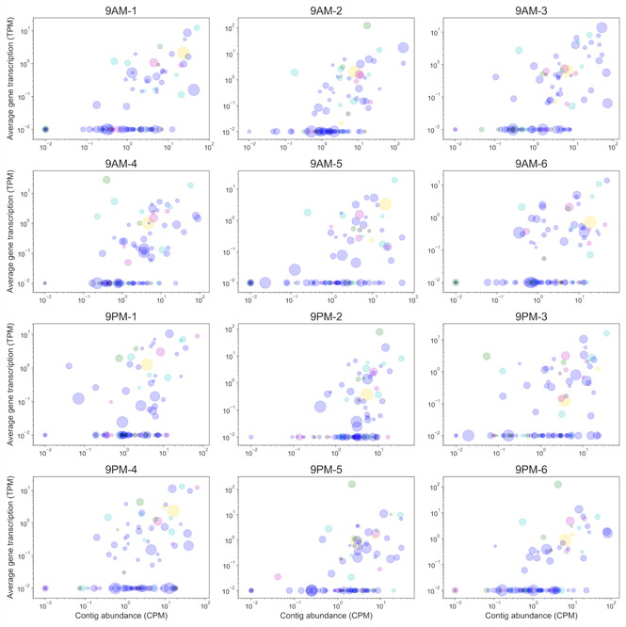

*Fig S3: Viral contig total transcriptional activity (TPM) and abundance (CPM) across the 12 replicates.*



*Fig. S4: Distribution of Pearson correlation in viral contigs of total transcriptional activity (TPM) and total abundance (CPM) across the 12 replicates.*

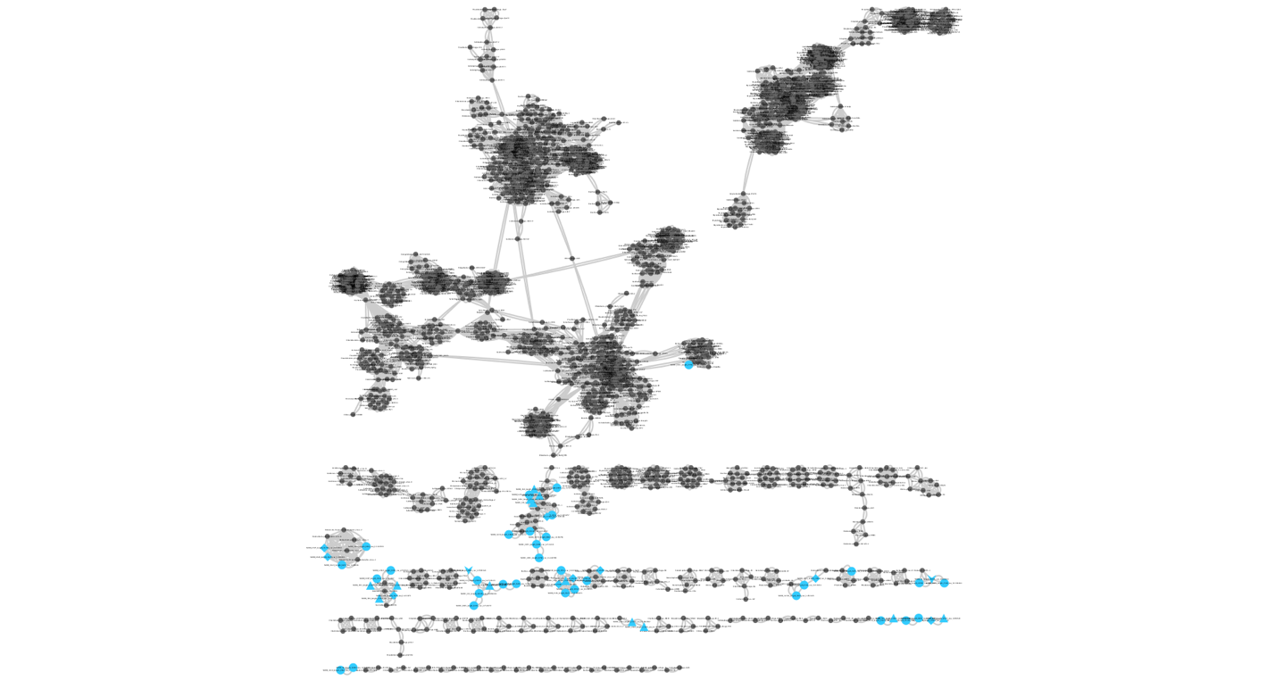

*Fig. S5: Tree of viruses and their predicted taxa? Mike? This section is very open-ended – feel free to add whatever you like at this point.*

 

*Fig S6: (A) An unrooted phylogenetic tree of a random subset of 500 Chlorophyta (green algae) species from the SILVA database, including all available sequences from the Mamiellophyceae class (highlighted in blue), constructed from a multiple alignment of 18S rRNA sequences,. (B) Zoomed-in view of the Mamiellophyceae class phylogeny, showing clustering of the 18S rRNA sequence from the halite algae (this study) together with members of the Dolichomastix genus (highlighted in blue).*

*Fig. S7: (A) The distribution of isoelectric points (pI) of predicted genes in various algal genomes, including the novel Dolichomastix.*



*Fig. S8: Relative prevalence of major KEGG functional pathways in the metagenomic (red) and metatranscriptomic (blue) samples. The pathway abundance (DNA) and expression (RNA) value were the combined total CPM or TPM (respectively) of the genes that constitute that pathway. All samples were standardized to an equal total coverage of pathways.*



*Fig. S9: The mean relative transcriptional activity ratio of major highly-expressed KEGG pathways in the major taxa found in the halite communities. The relative activity is taken to be the ratio of total pathway expression (TPM) to the pathway’s abundance (CPM) in each taxa.*

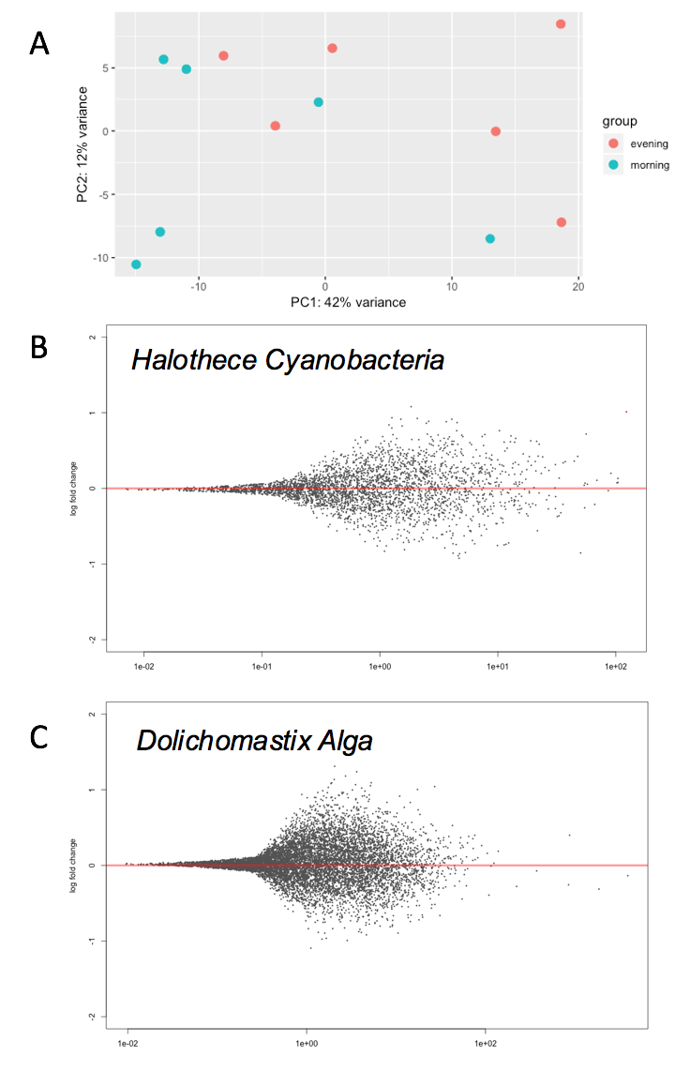

*Fig S10. DESeq differential expression analysis of the halite community between the morning (9am) and evening (9pm) time points. (A) Lack of significant clustering between the time points shown with a PCA of the expression profile of the entire community. (B) Lack of significantly differentially expressed genes (q-value<0.01) in the Halothece and (C) alga mag. Gene expression was expressed as transcripts per million (TPM), further standardized to the total transcription of the contig (A) or MAG (B,C) that they belong on to account for inter-replicate variation in abundance and activity.*



*Fig. S11: Variance in pathway abundance in the metagenome replicates (cyan) compared to the variance in pathway expression in metatranscriptome replicates (gold) shown in various taxon ground found in the halite communities.*

**References**

1. Uritskiy G, DiRuggiero J. Applying Genome-Resolved Metagenomics to Deconvolute the Halophilic Microbiome. Genes (Basel). 2019;10(3).

2. Gelsinger DR, DiRuggiero J. Transcriptional Landscape and Regulatory Roles of Small Noncoding RNAs in the Oxidative Stress Response of the Haloarchaeon Haloferax volcanii. J Bacteriol. 2018;200(9).

3. Crits-Christoph A, Gelsinger DR, Ma B, Wierzchos J, Ravel J, Davila A, et al. Functional interactions of archaea, bacteria and viruses in a hypersaline endolithic community. Environ Microbiol. 2016;18(6):2064-77.

4. Ramos-Barbero MD, Martin-Cuadrado A-B, Viver T, Santos F, Martinez-Garcia M, Antón J. Recovering microbial genomes from metagenomes in hypersaline environments: the Good, the Bad and the Ugly. Systematic and Applied Microbiology. 2018.

5. Davila AF, Hawes I, Garcia J, Gelsinger DR, DiRuggiero J, Ascaso C, et al. In situ metabolism in halite endolithic microbial communities of the hyperarid Atacama Desert. Front Microbiol. 2015;<http://dx.doi.org/10.3389/fmicb.2015.01035>.

6. Robinson CK, Wierzchos J, Black C, Crits-Christoph A, Ma B, Ravel J, et al. Microbial diversity and the presence of algae in halite endolithic communities are correlated to atmospheric moisture in the hyper-arid zone of the Atacama Desert. Environ Microbiol. 2015;17:299-315.

7. Uritskiy G, Getsin S, Munn A, Gomez-Silva B, Davila A, Glass B, et al. Halophilic microbial community compositional shift after a rare rainfall in the Atacama Desert. ISME J. 2019.

8. Finstad KM, Probst AJ, Thomas BC, Andersen GL, Demergasso C, Echeverria A, et al. Microbial Community Structure and the Persistence of Cyanobacterial Populations in Salt Crusts of the Hyperarid Atacama Desert from Genome-Resolved Metagenomics. Front Microbiol. 2017;8:1435.

9. Amato P, Besaury L, Joly M, Penaud B, Deguillaume L, Delort AM. Metatranscriptomic exploration of microbial functioning in clouds. Sci Rep. 2019;9(1):4383.

10. Tripathy S, Padhi SK, Mohanty S, Samanta M, Maiti NK. Analysis of the metatranscriptome of microbial communities of an alkaline hot sulfur spring revealed different gene encoding pathway enzymes associated with energy metabolism. Extremophiles. 2016;20(4):525-36.

11. Edwardson CF, Hollibaugh JT. Metatranscriptomic analysis of prokaryotic communities active in sulfur and arsenic cycling in Mono Lake, California, USA. ISME J. 2017;11(10):2195-208.

12. Louca S, Jacques SMS, Pires APF, Leal JS, Srivastava DS, Parfrey LW, et al. High taxonomic variability despite stable functional structure across microbial communities. Nat Ecol Evol. 2016;1(1):15.

13. Uritskiy G, Getsin S, Munn A, Gomez-Silva B, Davila A, Glass B, et al. Response of extremophile microbiome to a rare rainfall reveals a two-step adaptation mechanism. bioRxiv. 2018.

14. Fortunato CS, Larson B, Butterfield DA, Huber JA. Spatially distinct, temporally stable microbial populations mediate biogeochemical cycling at and below the seafloor in hydrothermal vent fluids. Environ Microbiol. 2018;20(2):769-84.

15. Heidelberg KB, Nelson WC, Holm JB, Eisenkolb N, Andrade K, Emerson JB. Characterization of eukaryotic microbial diversity in hypersaline Lake Tyrrell, Australia. Front Microbiol. 2013;4:115.

16. Liska AJ, Shevchenko A, Pick U, Katz A. Enhanced photosynthesis and redox energy production contribute to salinity tolerance in Dunaliella as revealed by homology-based proteomics. Plant Physiol. 2004;136(1):2806-17.

17. Katz A, Waridel P, Shevchenko A, Pick U. Salt-induced changes in the plasma membrane proteome of the halotolerant alga Dunaliella salina as revealed by blue native gel electrophoresis and nano-LC-MS/MS analysis. Mol Cell Proteomics. 2007;6(9):1459-72.

18. Meslier V, Casero MC, Dailey M, Wierzchos J, Ascaso C, Artieda O, et al. Fundamental drivers for endolithic microbial community assemblies in the hyperarid Atacama Desert. Environ Microbiol. 2018;20(5):1765-81.

19. Davila AF, Hawes I, Ascaso C, Wierzchos J. Salt deliquescence drives photosynthesis in the hyperarid Atacama Desert. Environ Microbial. 2013(DOI: 10.1111/1758-2229.12050).

20. Davila AF, Hawes I, Araya JG, Gelsinger DR, DiRuggiero J, Ascaso C, et al. In situ metabolism in halite endolithic microbial communities of the hyperarid Atacama Desert. Front Microbiol. 2015;6:1035.

21. Franzosa EA, Morgan XC, Segata N, Waldron L, Reyes J, Earl AM, et al. Relating the metatranscriptome and metagenome of the human gut. Proc Natl Acad Sci U S A. 2014;111(22):E2329-38.

22. Lopez-Fernandez M, Simone D, Wu X, Soler L, Nilsson E, Holmfeldt K, et al. Metatranscriptomes Reveal That All Three Domains of Life Are Active but Are Dominated by Bacteria in the Fennoscandian Crystalline Granitic Continental Deep Biosphere. Mbio. 2018;9(6).

23. Hamm JN, Erdmann S, Eloe-Fadrosh EA, Angeloni A, Zhong L, Brownlee C, et al. Unexpected host dependency of Antarctic Nanohaloarchaeota. Proc Natl Acad Sci U S A. 2019;116(29):14661-70.

24. Ron Milo RP. Cell Biology by the Numbers: Garland Science; 2016.

25. Comtet-Marre S, Parisot N, Lepercq P, Chaucheyras-Durand F, Mosoni P, Peyretaillade E, et al. Metatranscriptomics Reveals the Active Bacterial and Eukaryotic Fibrolytic Communities in the Rumen of Dairy Cow Fed a Mixed Diet. Front Microbiol. 2017;8:67.

26. Chen H, Jiang JG. Osmotic responses of Dunaliella to the changes of salinity. J Cell Physiol. 2009;219(2):251-8.

27. Elevi Bardavid R, Oren A. Acid-shifted isoelectric point profiles of the proteins in a hypersaline microbial mat: an adaptation to life at high salt concentrations? Extremophiles. 2012;16(5):787-92.

28. Broman E, Sachpazidou V, Dopson M, Hylander S. Diatoms dominate the eukaryotic metatranscriptome during spring in coastal 'dead zone' sediments. Proc Biol Sci. 2017;284(1864).

29. Engelhard C, Chizhov I, Siebert F, Engelhard M. Microbial Halorhodopsins: Light-Driven Chloride Pumps. Chem Rev. 2018;118(21):10629-45.

30. Grote M, O'Malley MA. Enlightening the life sciences: the history of halobacterial and microbial rhodopsin research. FEMS Microbiol Rev. 2011;35(6):1082-99.

31. Ernst OP, Lodowski DT, Elstner M, Hegemann P, Brown LS, Kandori H. Microbial and animal rhodopsins: structures, functions, and molecular mechanisms. Chem Rev. 2014;114(1):126-63.

32. Uritskiy GV, DiRuggiero J, Taylor J. MetaWRAP-a flexible pipeline for genome-resolved metagenomic data analysis. Microbiome. 2018;6(1):158.

33. Kopylova E, Noe L, Touzet H. SortMeRNA: fast and accurate filtering of ribosomal RNAs in metatranscriptomic data. Bioinformatics. 2012;28(24):3211-7.

34. Nurk S, Meleshko D, Korobeynikov A, Pevzner PA. metaSPAdes: a new versatile metagenomic assembler. Genome Res. 2017;27(5):824-34.

35. Patro R, Duggal G, Love MI, Irizarry RA, Kingsford C. Salmon provides fast and bias-aware quantification of transcript expression. Nat Methods. 2017;14(4):417-9.

36. Chen IA, Markowitz VM, Chu K, Palaniappan K, Szeto E, Pillay M, et al. IMG/M: integrated genome and metagenome comparative data analysis system. Nucleic Acids Res. 2017;45(D1):D507-D16.

37. Kanehisa M, Sato Y, Kawashima M, Furumichi M, Tanabe M. KEGG as a reference resource for gene and protein annotation. Nucleic Acids Res. 2016;44(D1):D457-62.

38. Love MI, Huber W, Anders S. Moderated estimation of fold change and dispersion for RNA-seq data with DESeq2. Genome Biol. 2014;15(12):550.

39. Besemer J, Lomsadze A, Borodovsky M. GeneMarkS: a self-training method for prediction of gene starts in microbial genomes. Implications for finding sequence motifs in regulatory regions. Nucleic Acids Res. 2001;29(12):2607-18.

40. Wu S, Zhu Y. ProPAS: standalone software to analyze protein properties. Bioinformation. 2012;8(3):167-9.

41. Paez-Espino D, Pavlopoulos GA, Ivanova NN, Kyrpides NC. Nontargeted virus sequence discovery pipeline and virus clustering for metagenomic data. Nat Protoc. 2017;12(8):1673-82.